**Check Packing Liquid Level Before Each Use**

**Step-by-Step Process for Setting Packing Level in a Wet-Type Gas Meter**

1. Depressurize gas meter by disconnecting all gas lines.
2. Unscrew filling nozzle cap (Figure 2 - Item 7)
3. Unscrew HPLI Screw Cap, if equipped. (Figure 5 -Item 1)
4. Place nipple into outlet gas connection to depressurize outlet (Figure 6)
5. Drain 500 mL of water into calibrated measuring cup using the drain (Figure 2 - Item 11)
6. Verify meter is level using level on meter (Figure 1)

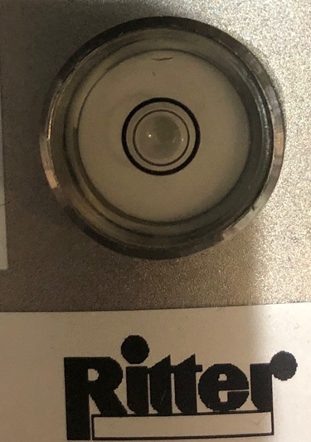

Figure 1: Meter level

1. Liquid Level Indicator
2. Open ball valve (Figure 2 - Item 10) on rear of gas meter.
3. Using water that was drained into the calibrated measuring cup in step 5, start slowing filling the meter in the filling nozzle (Figure 2 - Item 7)
4. Fill the gas meter housing until the liquid column in the level indictor starts to overflow.
5. Wait for it to stop dripping
6. Close ball valve (Figure 2 - Item 10) on rear of gas meter.
7. Setting Calibration
   1. Read HPLI and mL settings on the calibration sheet. (Verify total mL value on a scale. 1 mL of water = 1 gram of water)
      1. Serial Number: 1.544.7HI
         1. HPLI = +0.3
         2. Subtract 480 mL or 480 grams
      2. Serial Number 1.544.8HI
         1. HPLI = +0.5
         2. Subtract 290 mL or 290 grams
      3. Serial Number 1.544.5HI
         1. HPLI = -0.5
         2. Subtract 300 mL or 300 grams
      4. Serial Number 0.54J.D8B
         1. HPLI = +0.0
         2. Subtract 540 mL or 540 grams
   2. Using the calibrated measuring cup, remove the exact mL amount specified in 8a. Using the drain (Figure 2 - Item 11). If you remove too much, simply place the excess back into the meter.
   3. Open ball valve (Figure 2 - Item 10) on rear of gas meter, allow level to stabilize, then close ball valve (Figure 2 - Item 10)
   4. Gently, tilt the meter forward, then place back normally. Do not allow fluid to drip out of HPLI. (Figure 4)
   5. Verify meter is level using level on meter (Figure 1)
   6. Verify HPLI setting listed on calibration sheet. Read the liquid level from the base of the meniscus arc.
   7. You may need to add/subtract a maximum of 50 mL to dial into the HPLI setting.
8. Re-assembly
   1. Install HPLI Screw Cap and tighten, if equipped. (Figure 5 -Item 1)
   2. Install and tighten filling nozzle cap (Figure 2 - Item 7)
   3. Verify Liquid Level Indicator ball valve is closed (Figure 2 - Item 10)
   4. Install Outlet Gas Line
   5. Install Inlet Gas Line
   6. Verify meter is level using level on meter (Figure 1). Keep in mind, the gas lines can alter the level slightly. It must be level when everything is installed.
9. Check for Leaks
   1. Check HPLI Screw Cap for leaks (Figure 5 -Item 1)
   2. Purge system and turn on product. Allow for 5 full rotations on gas meter.
   3. Turn off Water Heater and reset EDU 32 FP Display. Verify display reads 0 Liters
   4. With everything connected (including product), allow it to sit for 1 hour. Verify no leaks.

Figure 2: TG 10 – Backside of Gas Meter Figure 3: Liquid Level Setting

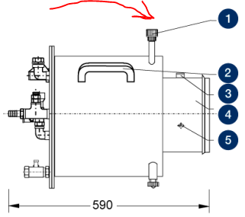

Figure 4: Tilt Gas Meter Forward Figure 5: HPLI Screw Cap

Figure 6: Outlet Nipple Installation